ĐẠI HỌC QUỐC GIA THÀNH PHỐ HỒ CHÍ MINH
TRƯỜNG ĐẠI HỌC CÔNG NGHỆ THÔNG TIN
KHOA MẠNG MÁY TÍNH VÀ TRUYỀN THÔNG




Computer Networking
Lab 02: Sniffing HTTP Traffic
with Wireshark

Overview

Goals
- Learn how to build a simple website yourself.
- Use Wireshark to capture HTTP packets to analyze the characteristics of these packets: GET/response messages, HTTP header structure, accessing long HTML files, accessing HTML files with attached objects, HTTP authentication and security,...

Knowledge base
- Knowledge of the HTTP protocol in the chapter 2 Application.

Experimental environment
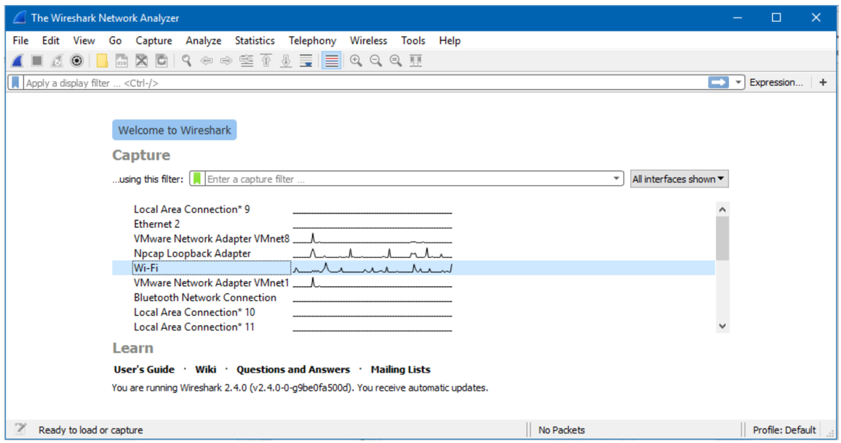
- Students need to prepare in advance a computer/laptop running Window/Linux/MacOS with Internet connection and download: https://www.wireshark.org/download.html
Figure 1. Main UI of Wireshark

Practise

Create a simple website on localhost

Create a website using a simple HTML file
- Open popular text editor likes Notepad, Notepad ++,…
- Copy-n-Paste the following content:
<!DOCTYPE html>
<html>
<head>
<title>Thực hành Mạng máy tính - 2022</title>
</head>
<body>
<center><img src=<url image http>/></center>
<center><h1>MSSV: 123456</h1></center>
<center><h2> Họ và tên: Nguyễn Văn An</h2></center>
</body>
</html>
At url image http, students find an image link on the Internet using http or students can add their own picture (learn more). For example, http://www.celuit.edu.vn/sites/default/files/photos/large/202110/kimg0816.jpg
Students can learn more about HTML at: http://www.w3schools.com/ to create your own HTML.
- Save the web page with the name MSSV.html (MSSV is the student ID of the student doing this lab).

Configure Internet Information Service (IIS) Webserver on Windows
- Enable IIS service (service to create Web/FTP server,...) on Windows 10 with the following steps: Control Panel Programs and features Turn Windows Features on or off Select Internet Information Service OK.
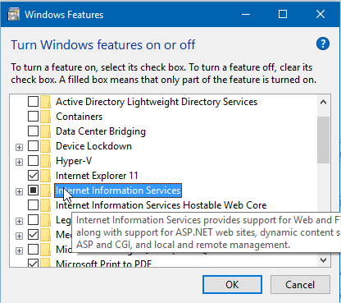
Figure 2. Enable IIS on Window
- Check if the service is up and running by typing the URL http://localhost into any browser, a default IIS Web page appears as success.
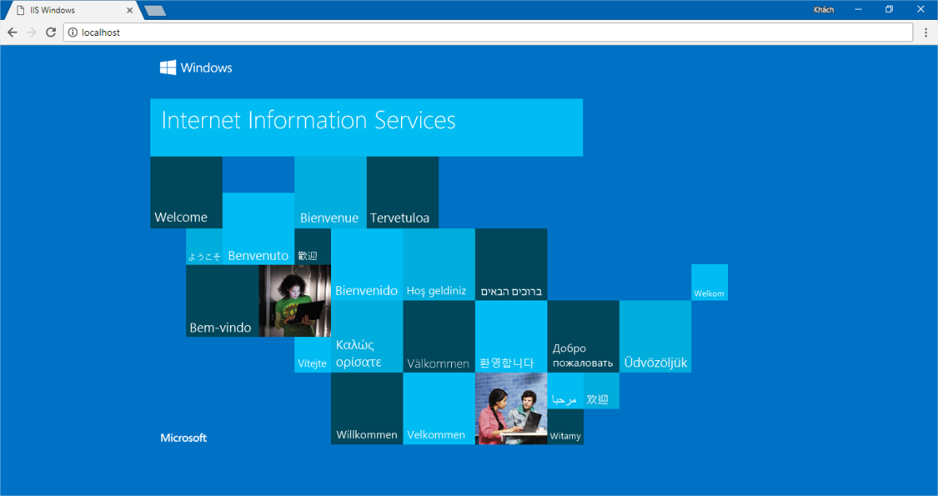
Figure 3. IIS default web page
- With different types of Windows, go to the search section to find Internet Information Services (IIS) Manager to be able to create Web pages on the server.
- To create a new Website, right-click Site Add Website. Set Sitename as MSSV (MSSV of students doing practice), Physical path is an arbitrary folder name.
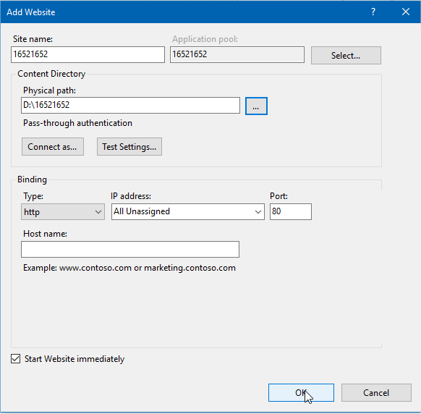
Figure 4. Add a new website with IIS
- Copy the MSSV.html file just created in part 1 to the folder specified in the Physical path section.
- Access your website using this link: http://localhost/MSSV.html
- Try accessing another student's website from a browser by typing the following URL:
A.B.C.D/MSSV.html
where A.B.C.D is the IP address of the computer your friend uses.
MSSV.html is the html file that my friend created.
Gợi ý: Students can quickly see the IP address of their computer by the following:
- Use the Windows + R key combination to open the Run window.
- Type cmd OK.
- Type ipconfig to see the IP address on your machine.
- If access is not possible, students turn off the firewall and try again.

The Basic HTTP GET/response interaction
Most web browsers support caching and perform HTTP GET conditions. Before performing the following steps, clear the browser cache (for Firefox, select ToolsClear Recent History and select the Cache box, or for Internet Explorer, select ToolsInternet OptionsDelete File).
Perform the following steps:
- Start the browser and make sure the browser cache is cleared.
- Start Wireshark and start capturing packets
- Visit other students' websites in class.
- Quickly enter that URL and visit it again (or select the refresh button on the browser).
Stop capturing packets and enter “http” in the display-filter window to display HTTP messages.
Answer the following questions with pictures demonstrating the results from Wireshark:
- Is the browser using HTTP version 1.0 or 1.1? What is the version of HTTP server in use?
- What is your computer's IP address? How much is the web server's?
- What is the status code returned from the server?
- How many bytes of content did the server return to the browser?
- Review the contents of HTTP GET first. You can see the line “IF-MODIFIED-SINCE” or not?
- Consider the content of the response from the server. Is the server really returning the contents of the file HTML or not? Why?
- Examine the contents of the 2nd HTTP GET. Do you see the line “IF-MODIFIED-SINCE” or not? If yes, what is the value of IF-MODIFIED-SINCE?
- What is the HTTP status code returned from the server corresponding to the 2nd HTTP GET? What does it mean? Is the server really sending back the contents of the file? Explanation.
- How many HTTP GETs did the browser send? To which IP addresses?

Accessing long HTTP pages
In our examples, the pages accessed are short and simple HTML files. We will see what happens when downloading a long HTML file:
Perform the following steps once you have an Internet connection:
- Start the web browser and make sure the cache is cleared.
- Start Wireshark and start capturing packets.
- From a browser, go to the following address: http://gaia.cs.umass.edu/wireshark-labs/HTTP-wireshark-file3.html
- Stop capturing packets and enter “http” in the display-filter window to display HTTP messages.
In the packet-listing window, you will see that the HTTP GET is followed by multiple TCP response packets. In our case, the HTML file has a long content, 4500 bytes is too big to fit in a TCP packet. Therefore, the HTTP response is split by TCP into many small packets, each of which is contained In a TCP segment. In recent Wireshark versions, Wireshark identifies each TCP segment as a separate packet, and the HTTP response message is decomposed into multiple TCP packets identified by the "TCP segment of reassembled PDU" line in the Info column. Older Wireshark versions use “Continuation”.
Answer the following questions:
- How many HTTP GETs did the browser send? The line “THE BILL OF RIGHTS” is contained in what response packet?
- How many TCP segments does it take to contain the HTTP response and the content of The Bill of Rights?

HTTP Authentication
Visit a password-protected website and observe the sequence of HTTP messages exchanged between the browser and that website. Website http://gaia.cs.umass.edu/wireshark-labs/protected_pages/HTTP-wireshark-file5.html is password protected with username “wireshark-students” (without quotes), and password “network” (without quotes).
Take the following steps when you have an Internet connection:
- Start the browser and make sure the cache is cleared.
- Start Wireshark and start capturing packets.
- From a browser, go to the following address http://gaia.cs.umass.edu/wireshark-labs/protected_pages/HTTP-wireshark- file5.html
- Type in username and password.
- Stop capturing packets and enter “http” in the display-filter window to display HTTP message.
- Check out the results of Wireshark.
Answer the following questions:
- What is the status code and what it means in the HTTP response corresponding to the first HTTP GET?
- When the browser sends the HTTP GET for the second time, what new fields appear in the HTTP GET?

THE END

